|  |  |
| --- | --- |
| AUE-8200-Perception and Intelligence  Homework-2 | Siddharth Thorat  CU-ICAR |

1. For [NuScene](https://www.nuscenes.org/download) dataset access, you may need to register on that website. To save time, you can download only the Full dataset/Mini set.

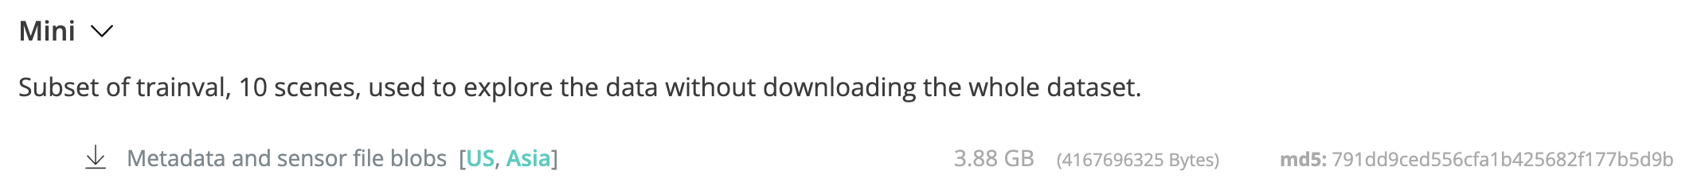

* I download Full NuScene dataset/Mini set from the “ [NuScene](https://www.nuscenes.org/download)” website into my documents and created a separate folder for all NuScene datasets.

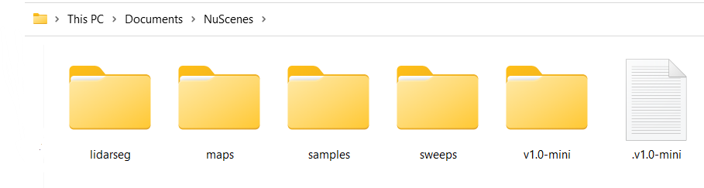

Figure 1

Path-Link: C:\Users\siddh\OneDrive\Pictures\Screenshots\Documents\NuScenes

1. If you use Python, set up the NuScene develop kit locally, you may need to install Anaconda and Jupyter notebook; If you use Matlab, setup your Matlab for this data process.

* I installed Anaconda and jupyter Notebook in my laptop to setup the NuScene develop kit locally.

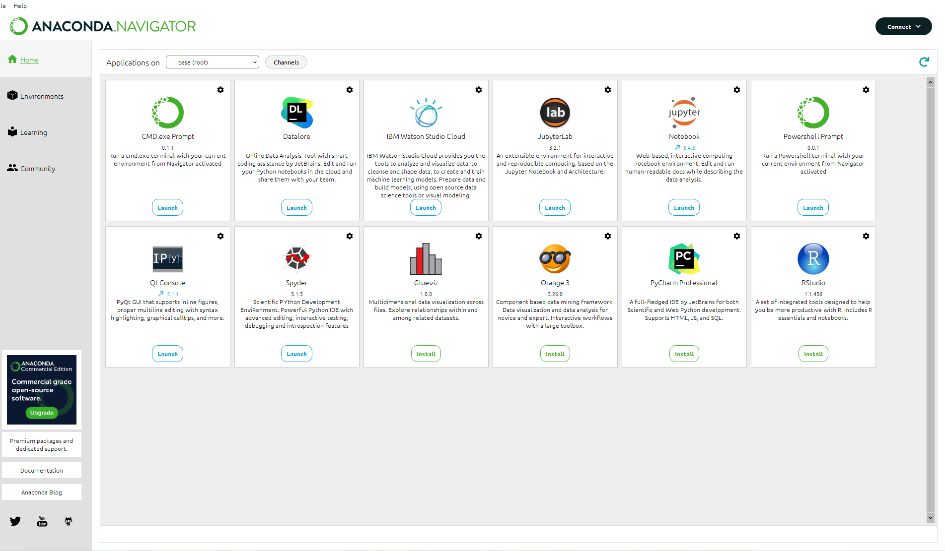

Figure 2

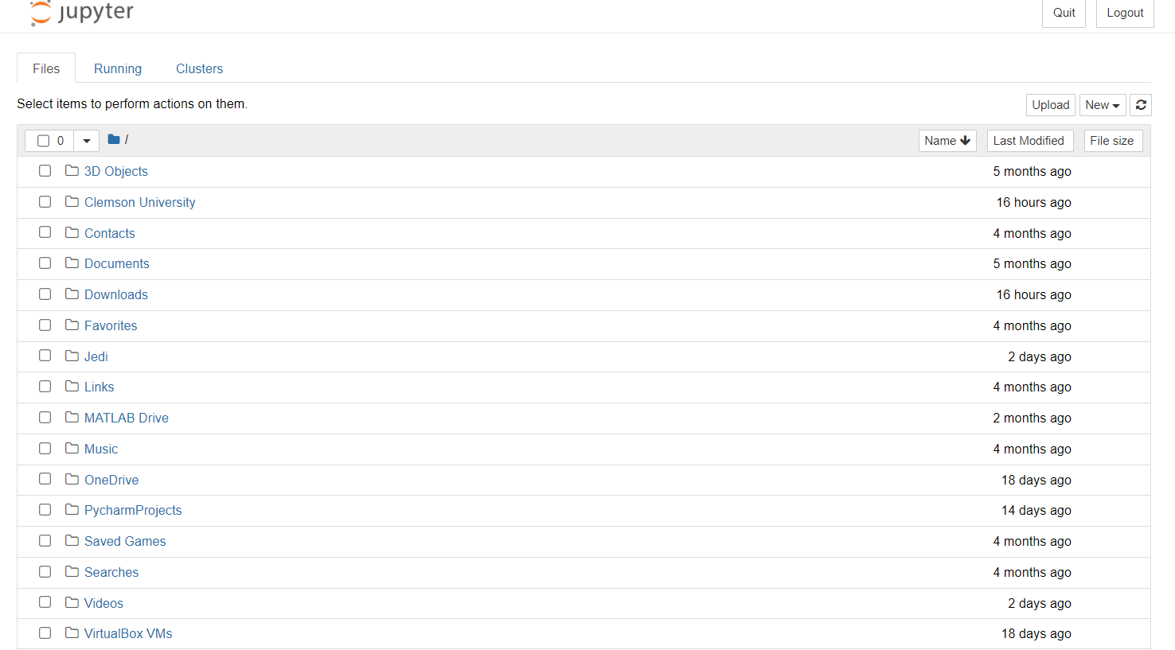

Figure 3

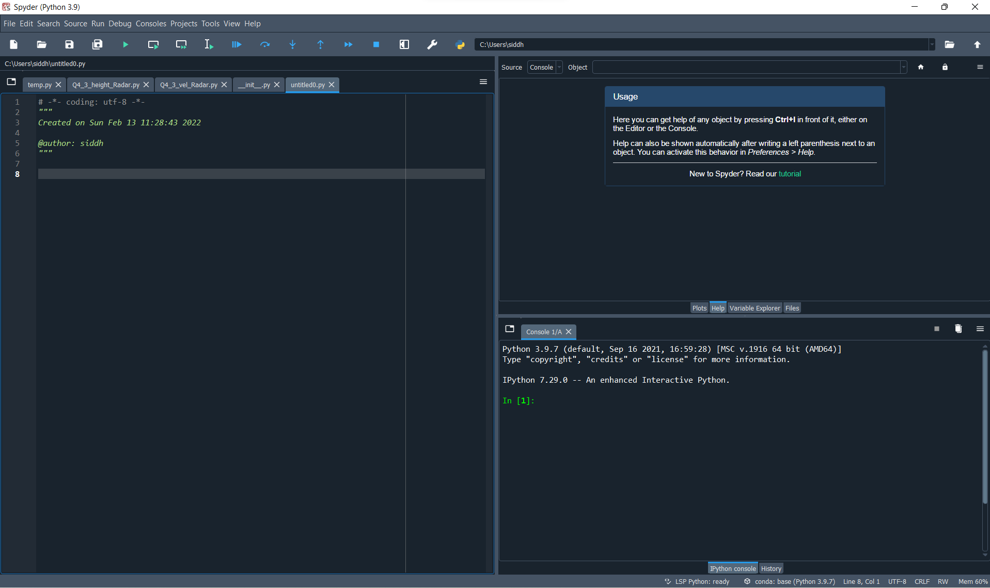

Figure 4

1. Pickup a set of data, including Image, Lidar, and Radar data. Visualize them respectively. If you use Python, you can refer to NuScene dev-kit tutorial.

* I have selected a set of data which includes Image, Lidar, and Radar data from the NuScenes dataset and visualized using Anaconda-Spyder

Program:

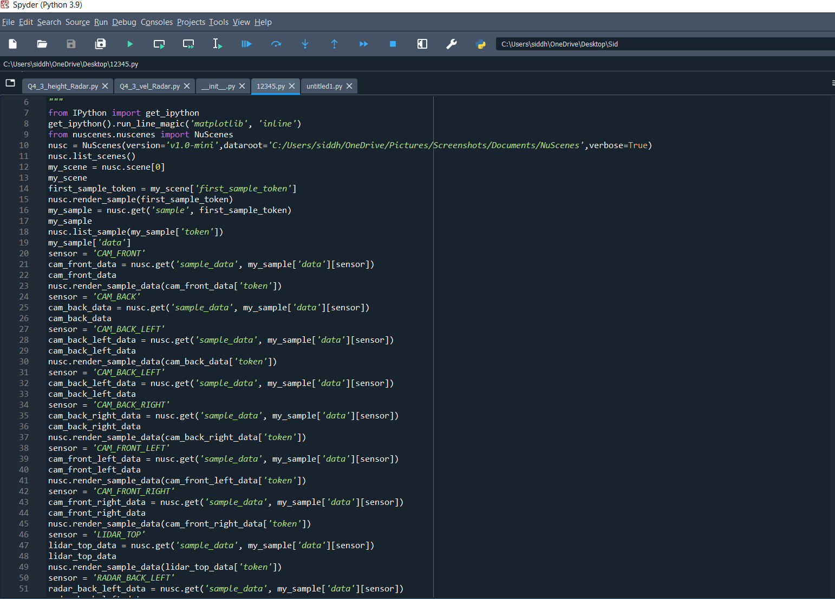

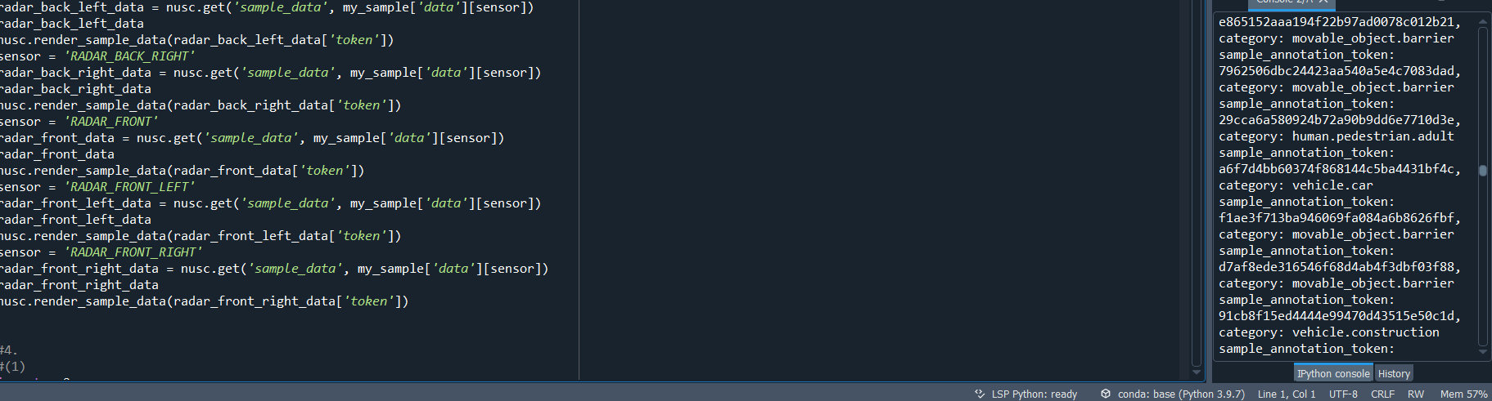

Visualization Plots:

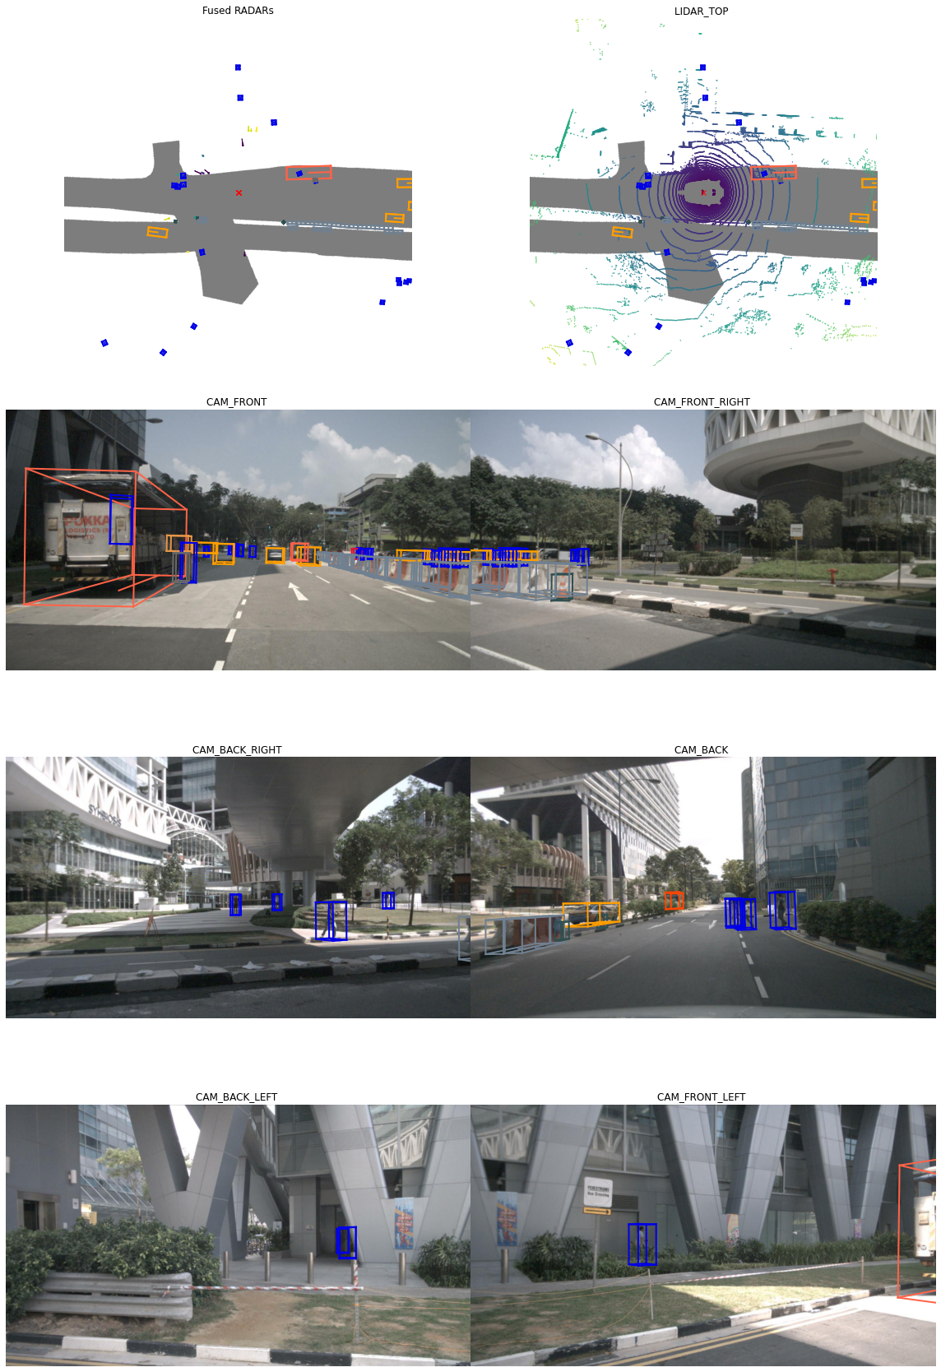

Figure 5

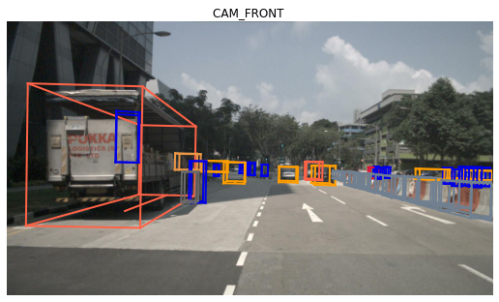

Figure 6

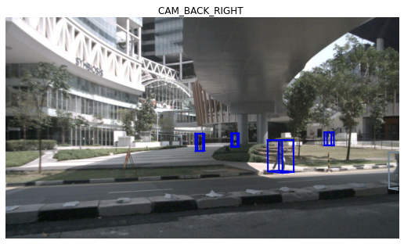

Figure 7

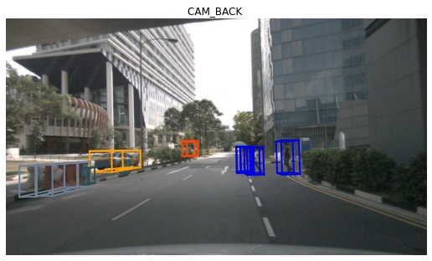

Figure 8

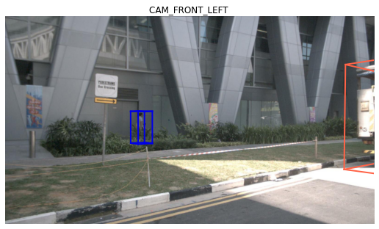

Figure 9

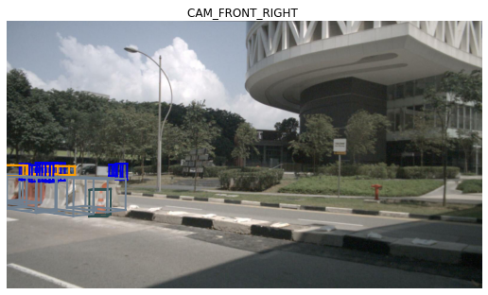

Figure 10

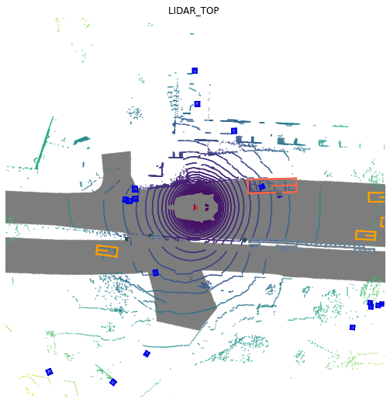

Figure 11

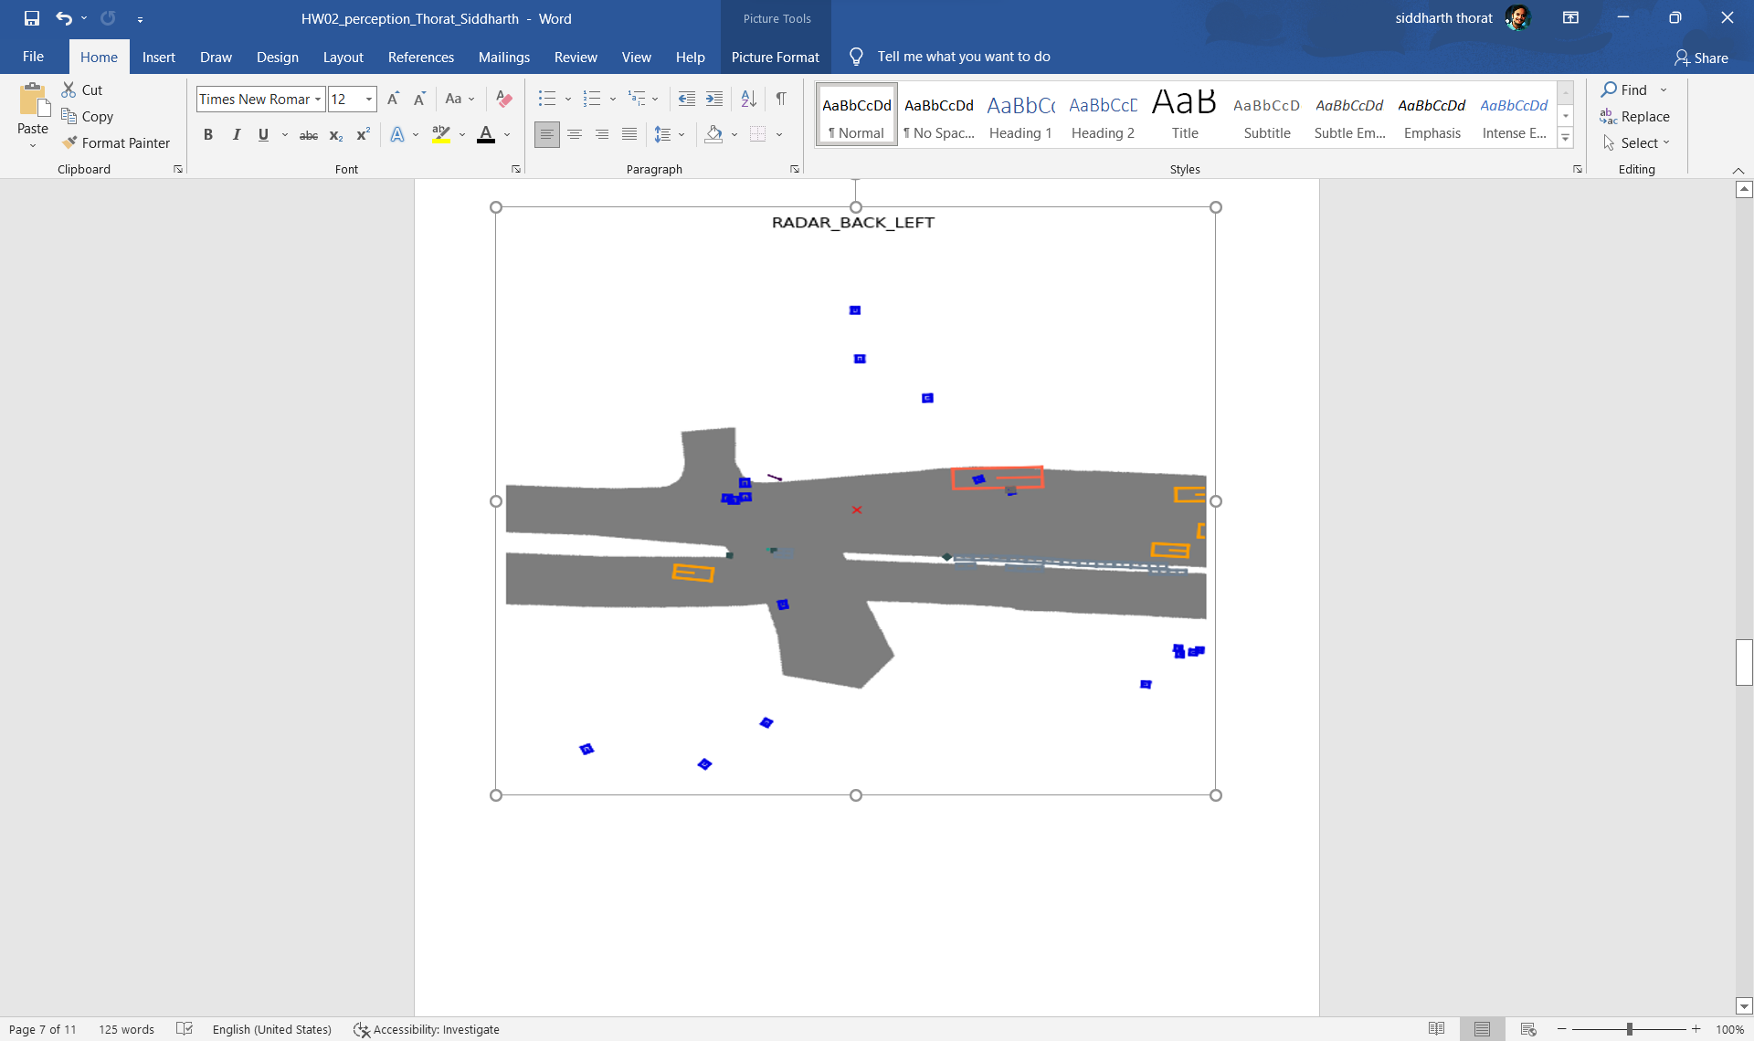

Figure 12

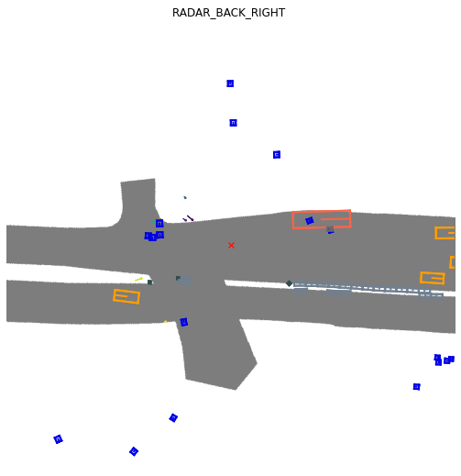

Figure 13

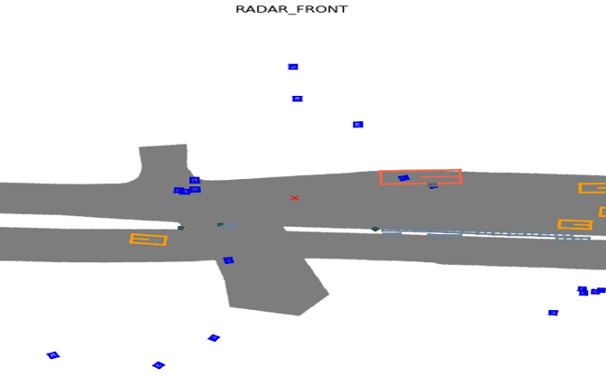

Figure 14

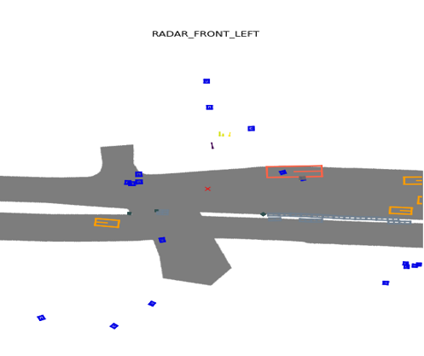

Figure 15

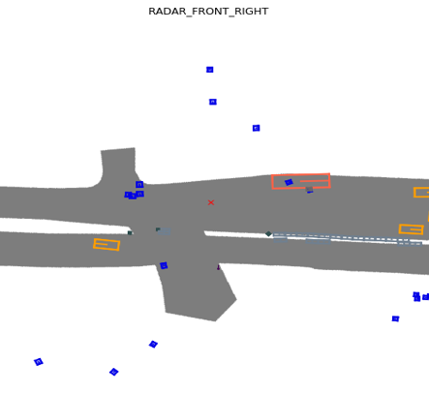

Figure 16

1. Rather than using NuScene dev-kit, implement below by yourself:
2. Visualize images (you can use library OpenCV or others.
3. Visualize Lidar point cloud data
   1. You can refer to this [sample code](https://github.com/fengziyue/AUE-8939-Perception-Intelligence/blob/main/Homework1/Visualize-Lidar.py).
   2. Colorize points by height, intensity, and semantic label respectively.
      1. Height is the Z value for a point.
      2. You can get intensity referring the code [here](https://github.com/nutonomy/nuscenes-devkit/blob/5325d1b400950f777cd701bdd5e30a9d57d2eaa8/python-sdk/nuscenes/utils/data_classes.py#L234).
      3. You can get semantic label from the sample above code.
4. Visualize Radar data
   1. Use any other library (e.g., Open3D, PCL, etcl) or modify the previous sample code to visualize the Radar data which you chosen.
   2. Colorize points by below two variable aspects respectively.
      1. For height (if it’s all zero, you can colorize the points by distance).
      2. For velocity, you can find some velocity information from [here](https://github.com/nutonomy/nuscenes-devkit/blob/5325d1b400950f777cd701bdd5e30a9d57d2eaa8/python-sdk/nuscenes/utils/data_classes.py#L259:1).

(1) Visualize images (you can use library OpenCV or others:

Program:

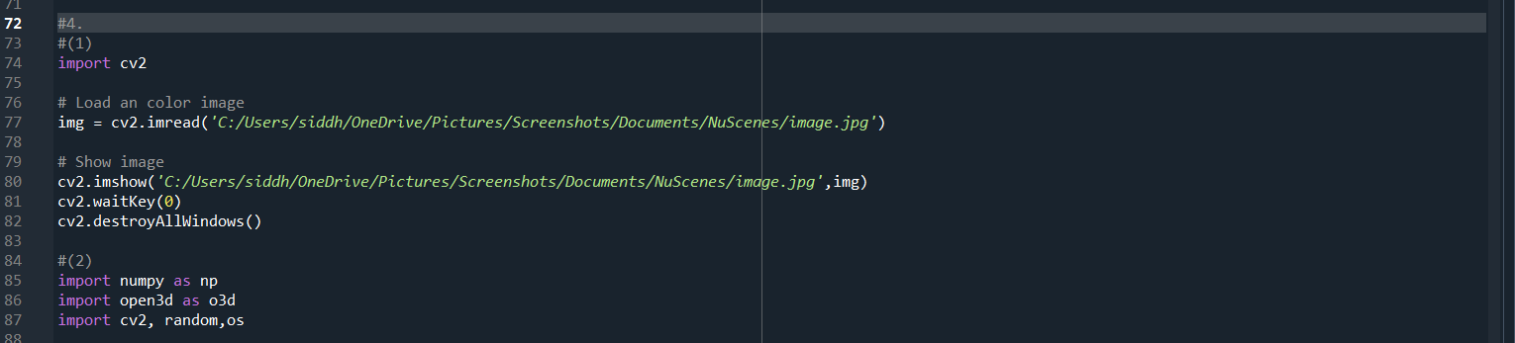

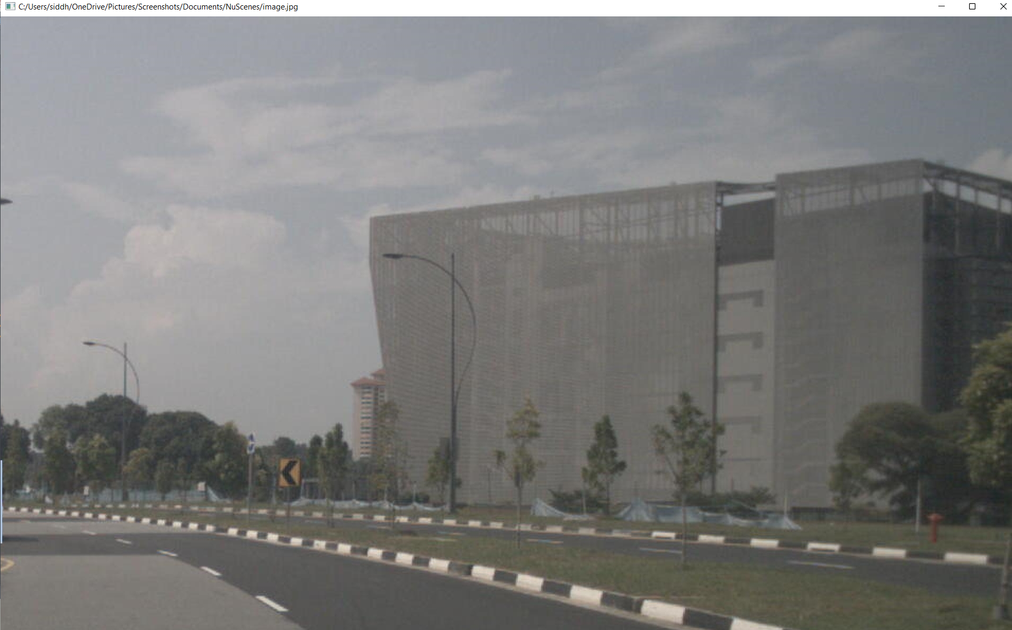

Figure 17

(2) Visualize Lidar point cloud data:

* 1. You can refer to this [sample code](https://github.com/fengziyue/AUE-8939-Perception-Intelligence/blob/main/Homework1/Visualize-Lidar.py).
  2. Colorize points by height, intensity, and semantic label respectively.
     1. Height is the Z value for a point.
     2. You can get intensity referring the code [here](https://github.com/nutonomy/nuscenes-devkit/blob/5325d1b400950f777cd701bdd5e30a9d57d2eaa8/python-sdk/nuscenes/utils/data_classes.py#L234).
     3. You can get semantic label from the sample above code.

e. Program:

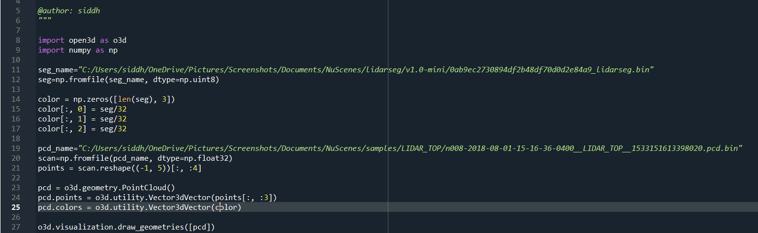

Visualization of Lidar Image:

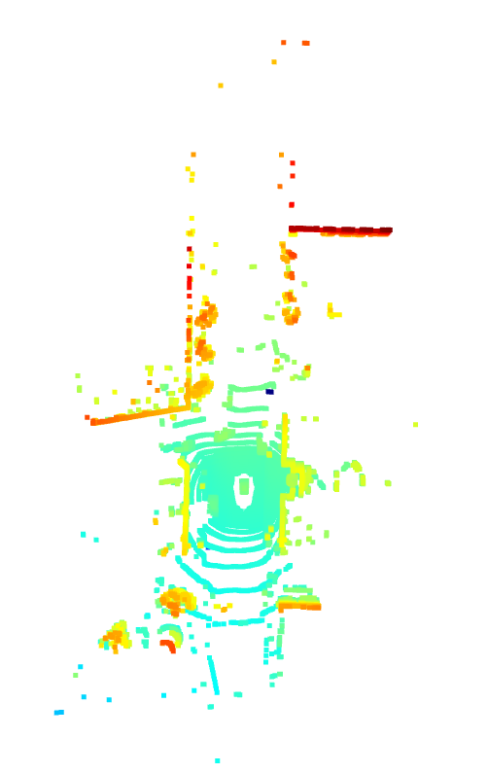

Figure 18

f. Program:

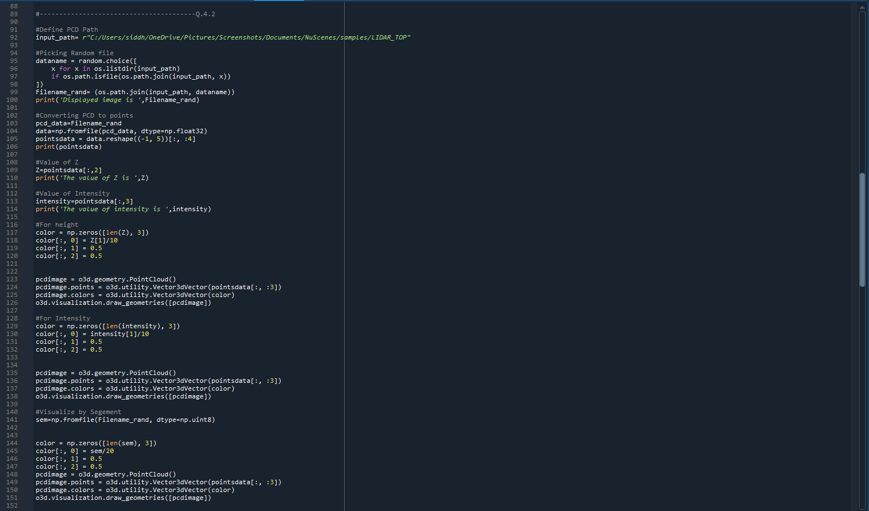

Visualizations of h\Height, Intensity, Segmantic label:

a. Height:

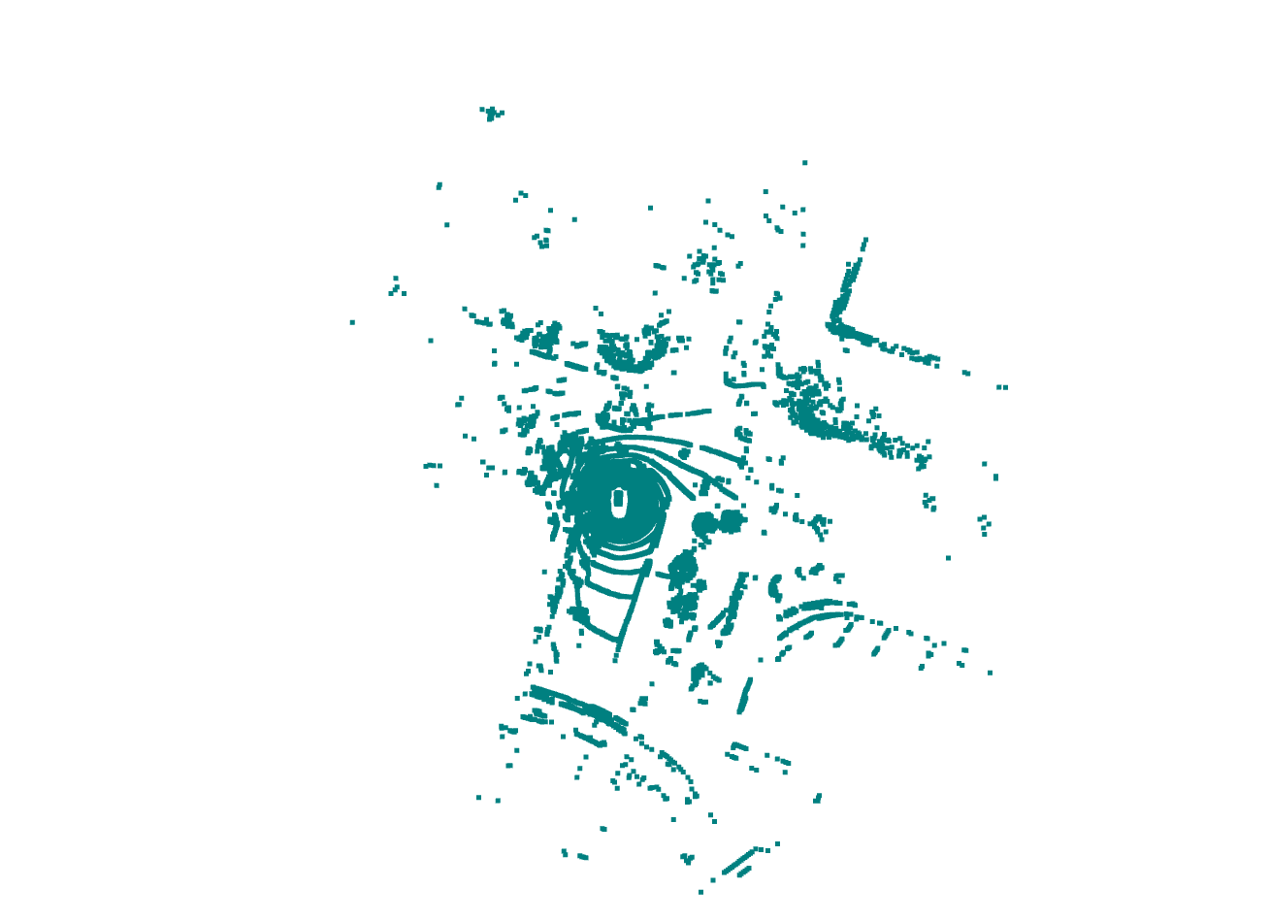

Figure 19

b. Intensity:

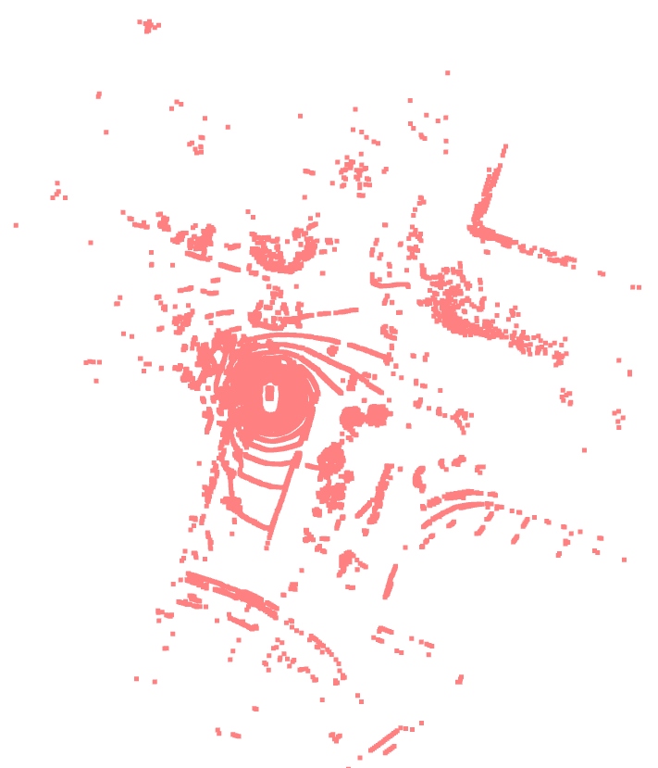

Figure 20

c. Segmantic label:

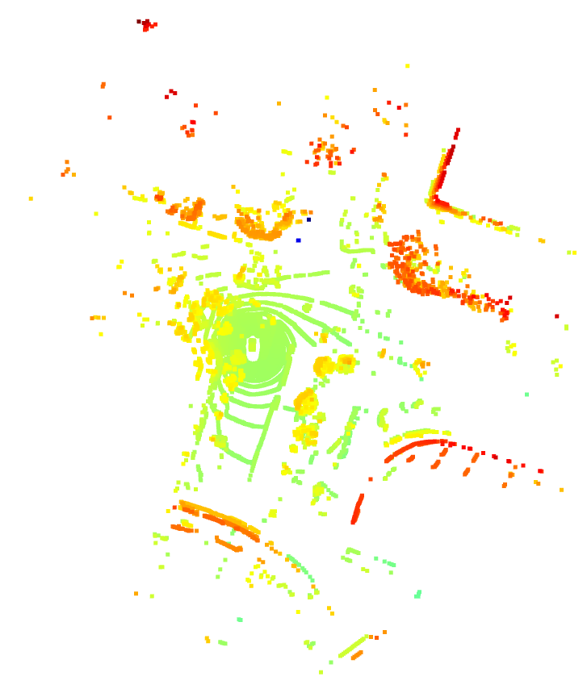

Figure 21

1. Visualize Radar data
   1. Use any other library (e.g., Open3D, PCL, etcl) or modify the previous sample code to visualize the Radar data which you chosen.
   2. Colorize points by below two variable aspects respectively.
      1. For height (if it’s all zero, you can colorize the points by distance).
      2. For velocity, you can find some velocity information from [here](https://github.com/nutonomy/nuscenes-devkit/blob/5325d1b400950f777cd701bdd5e30a9d57d2eaa8/python-sdk/nuscenes/utils/data_classes.py#L259:1).

g. Use any other library (e.g., Open3D, PCL, etcl) or modify the previous sample code to visualize the Radar data which you chosen.

Program:

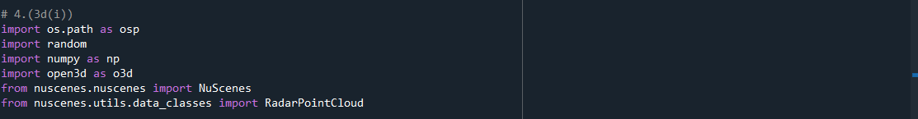

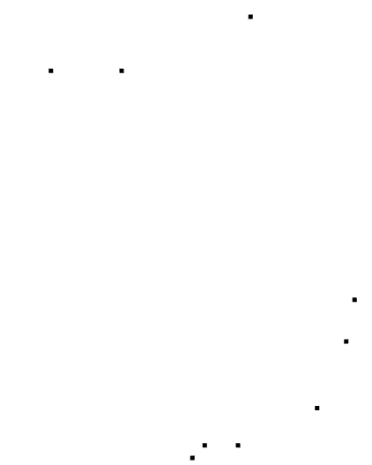

Figure 22

h. Colorize points by below two variable aspects respectively:

* + 1. For height (if it’s all zero, you can colorize the points by distance).
    2. For velocity, you can find some velocity information from [here](https://github.com/nutonomy/nuscenes-devkit/blob/5325d1b400950f777cd701bdd5e30a9d57d2eaa8/python-sdk/nuscenes/utils/data_classes.py#L259:1).

Program:

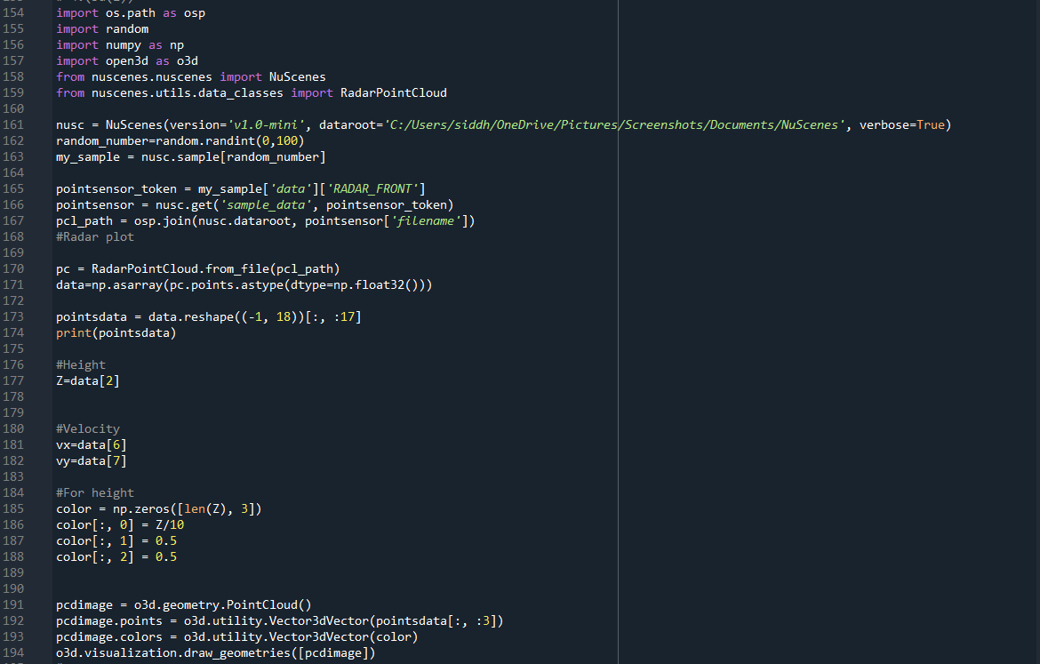

Visualization of height:



Figure 23

Program:

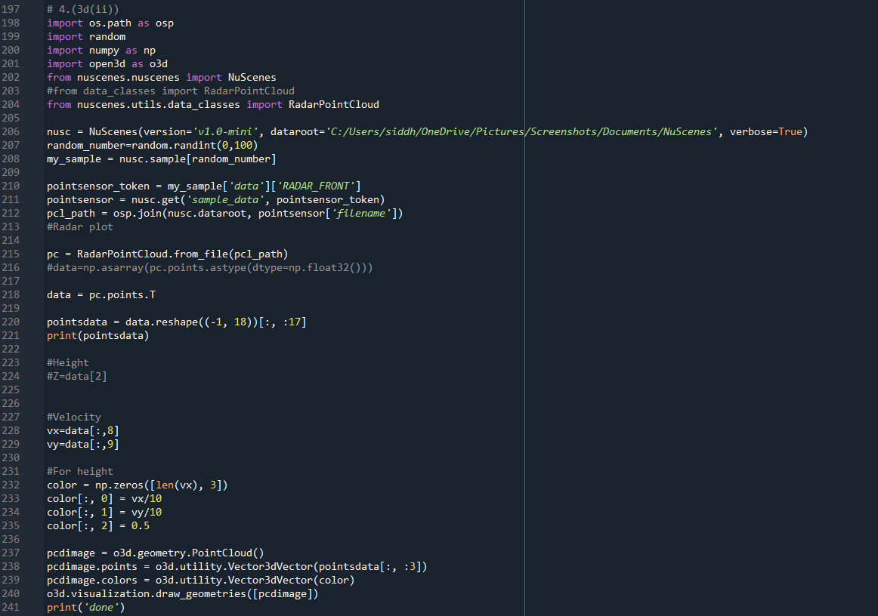

Visualization of velocity:

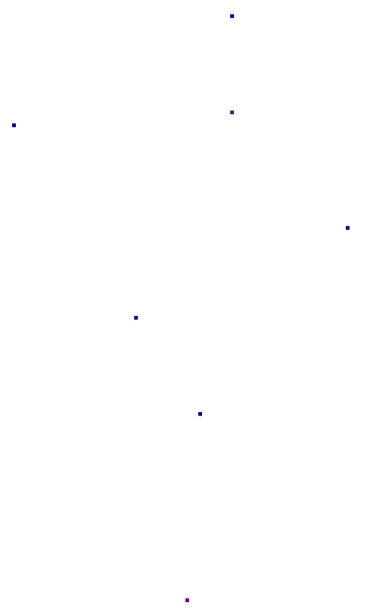

Figure 24

1. Using NuScene dev-kit for the set of data which you picked up:
2. Visualize Radar data projection on image
   1. Print calibration info (between Radar and Camera sensors) by referring code [here](https://github.com/nutonomy/nuscenes-devkit/blob/5325d1b400950f777cd701bdd5e30a9d57d2eaa8/python-sdk/nuscenes/nuscenes.py#L740).
   2. Explain the above calibration info, and pipeline of First~Fifth steps in the code.

c. Visualize Radar data projection on image based on calibration info.

a.

Program:

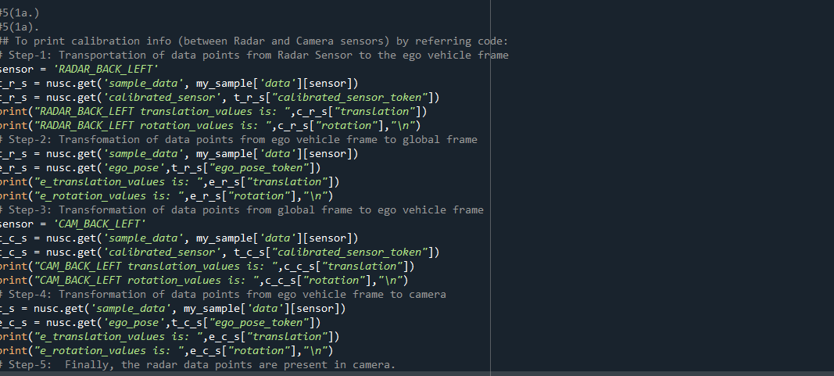

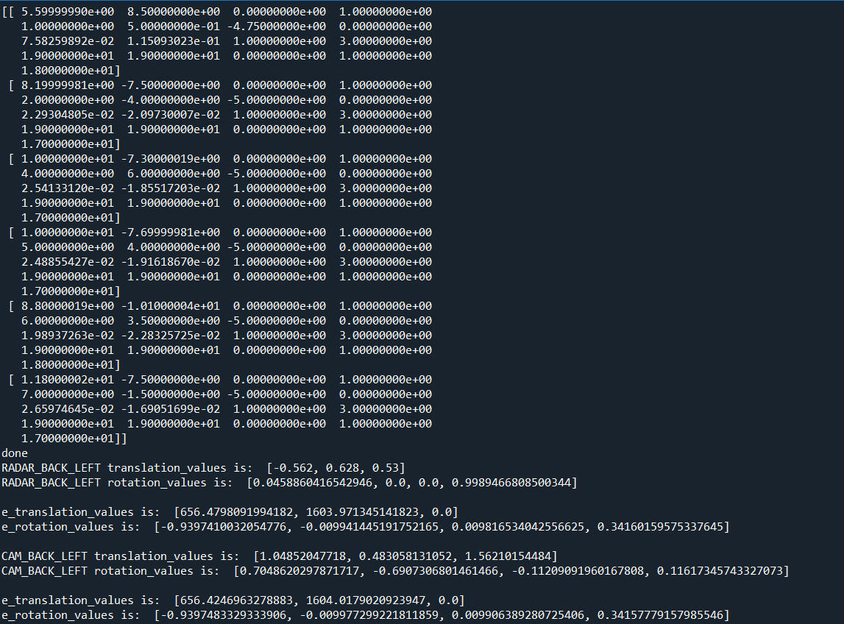

1b. Explain the above calibration info, and pipeline of First~Fifth steps in the code

* Firstly, the data points are transferred from the Radar sensor to ego vehicle frame by using (translation and rotation) calibration data.
* Secondly, the data points are transferred from ego vehicle frame to global frame by using ego pose in calibration data (translation and rotation).
* Thirdly, the data points are now transformed from global frame to ego vehicle frame by using calibration data (translation and rotating).
* Next, the data points are transformed from ego vehicle frame to the camera frame.
* Finally, the radar data points are present in the Camera.

1c. Visualize Radar data projection on image based on calibration info.

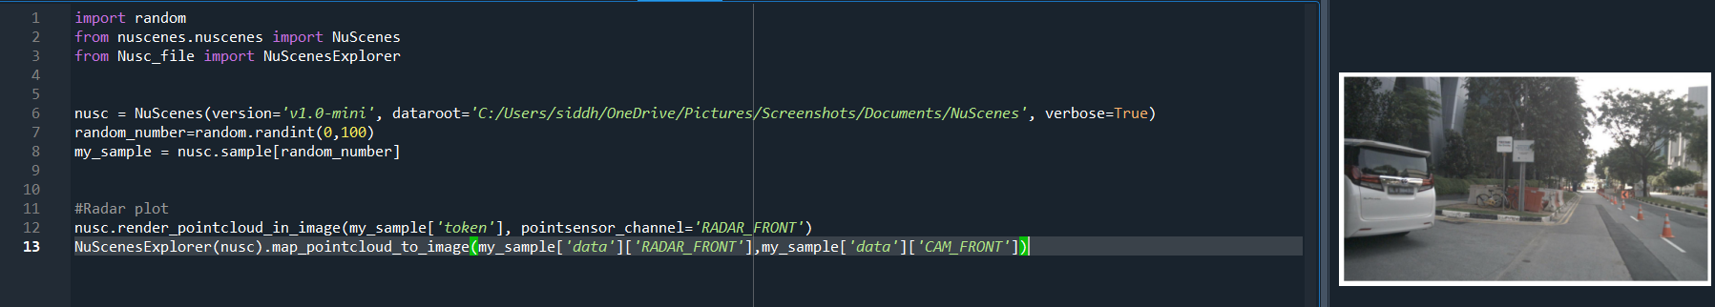

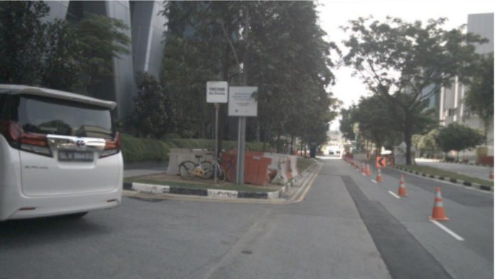

Figure 25

* If we observe keenly, we can see that they are blue and red colour-based distance values where Red is the maximum and Blue is the minimum.

1. Visualize LiDAR data projection on image
   1. Print and explain the calibration info (between LiDAR and Camera sensors) by referring [here](https://github.com/nutonomy/nuscenes-devkit/blob/5325d1b400950f777cd701bdd5e30a9d57d2eaa8/python-sdk/nuscenes/nuscenes.py#L740).

e. Visualize LiDAR data projection on image based on calibration info.

2c. Print and explain the calibration info (between LiDAR and Camera sensors:

Program:

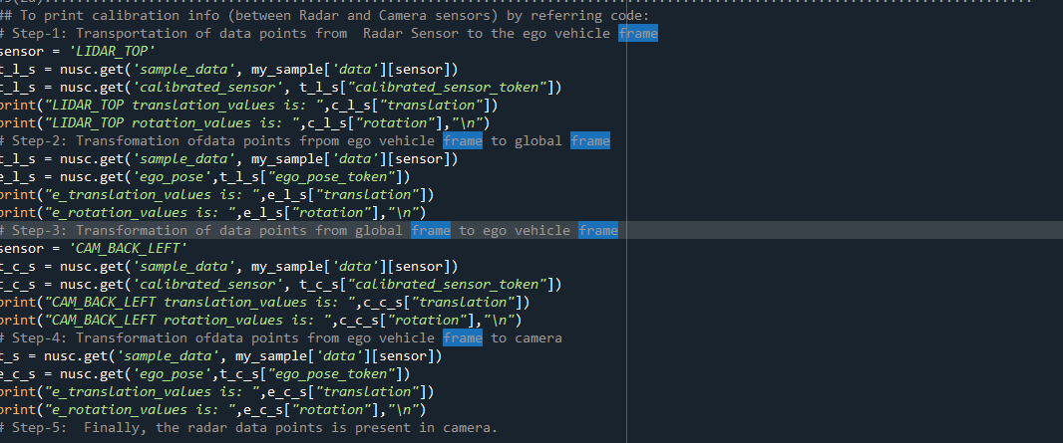

c. Explanation of above calibration info:

* Firstly, the data points are transferred from the Radar sensor to ego vehicle frame by using (translation and rotation) calibration data.
* Secondly, the data points are transferred from ego vehicle frame to global frame by using ego pose in calibration data (translation and rotation).
* Thirdly, the data points are now transformed from global frame to ego vehicle frame by using calibration data (translation and rotating).
* Next, the data points are transformed from ego vehicle frame to the camera frame.
* Finally, the radar data points are present in the Camera.

e. Visualize LiDAR data projection on image based on calibration info.

Program:

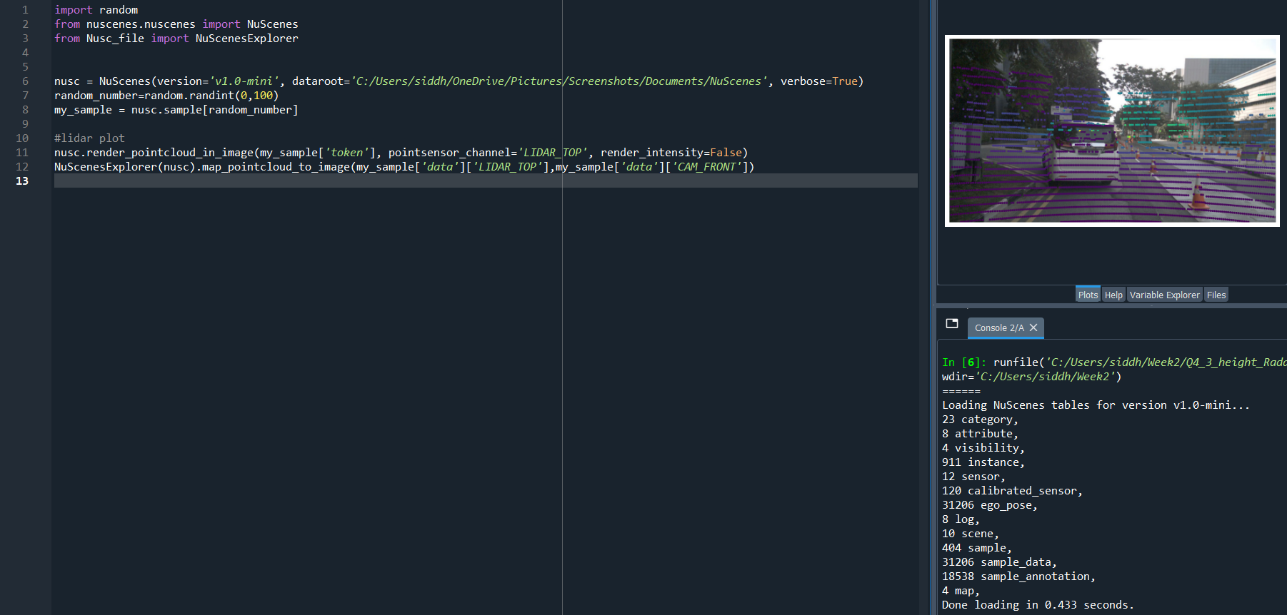

Visualization of LiDAR data projection on image based on calibration info:

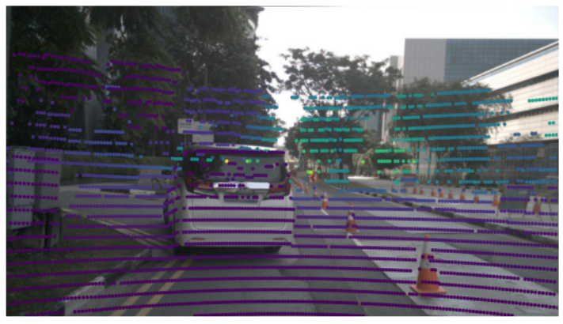

Figure 26